SAMPLE UPLOAD AND DOWNLOAD BY USING JMETER

* Open a thread group
* Create a new FTP request from the sampler
* 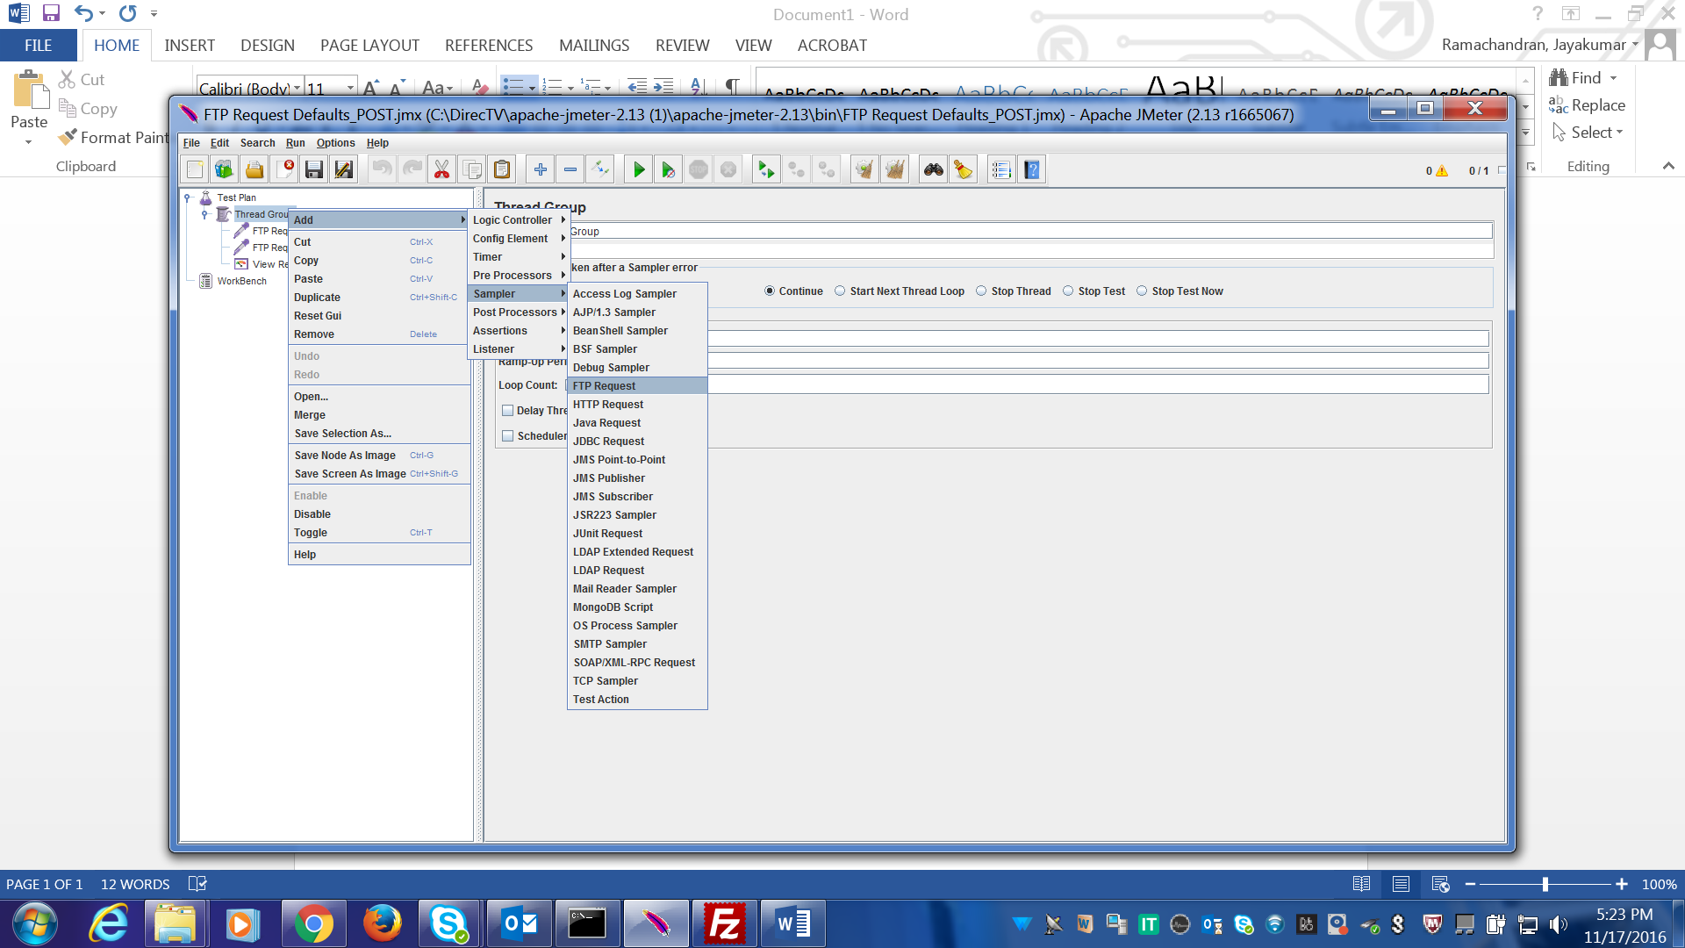

**FTP CLIENT SETUP:**

We need sample FTP server to test.

Go to <https://www.swfwmd.state.fl.us/data/ftp/>

Follow the steps

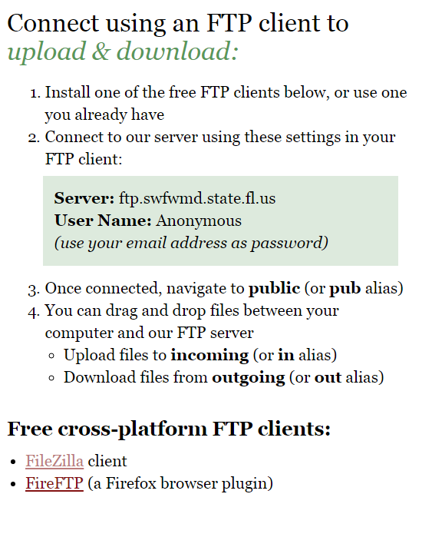

* Click on FileZilla client, download it and install it.

On the left side it shows our local files, right side it shows the remote machine (FTP Server) files

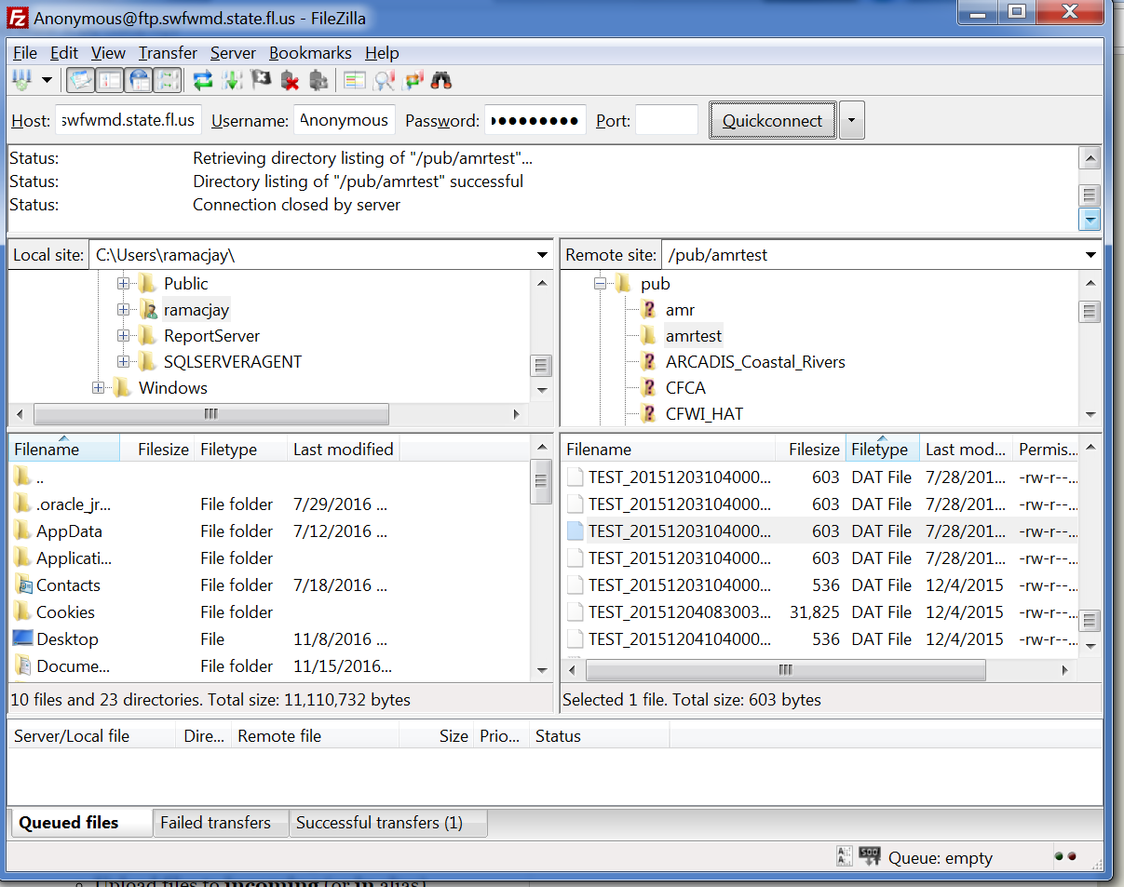

* Fill the server name [ftp.swfwmd.state.fl.us](ftp://ftp.swfwmd.state.fl.us)
* Give the remote file name location in the “Remote File”
* Mention your local file path where would you like to download or place the remote file
* For download go for the option “get(RETR)”
* Username – Anonymous
* Password – your email id

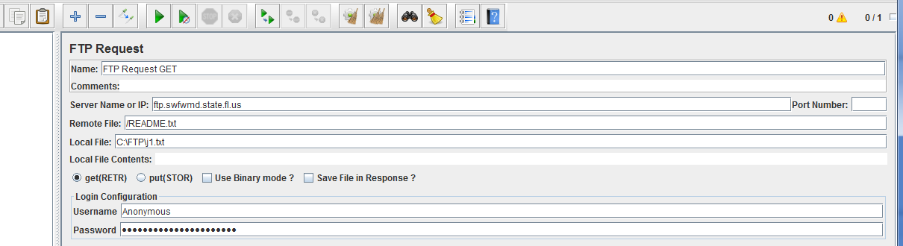

* Click on start in JMeter
* You can find the text file in the respective location
* 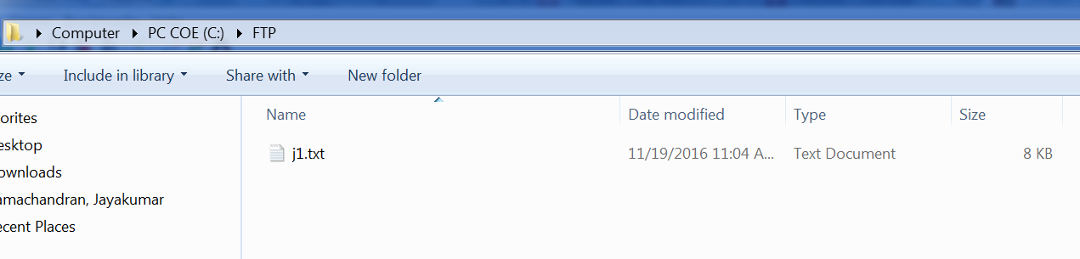

UPLOAD

* Create another FTP request from the sampler
* Follow the same process as mentioned the download
* For upload go for the option “PUT(STOR)”
* Give the file name locations for both the local and remote
* Click on the run button
* 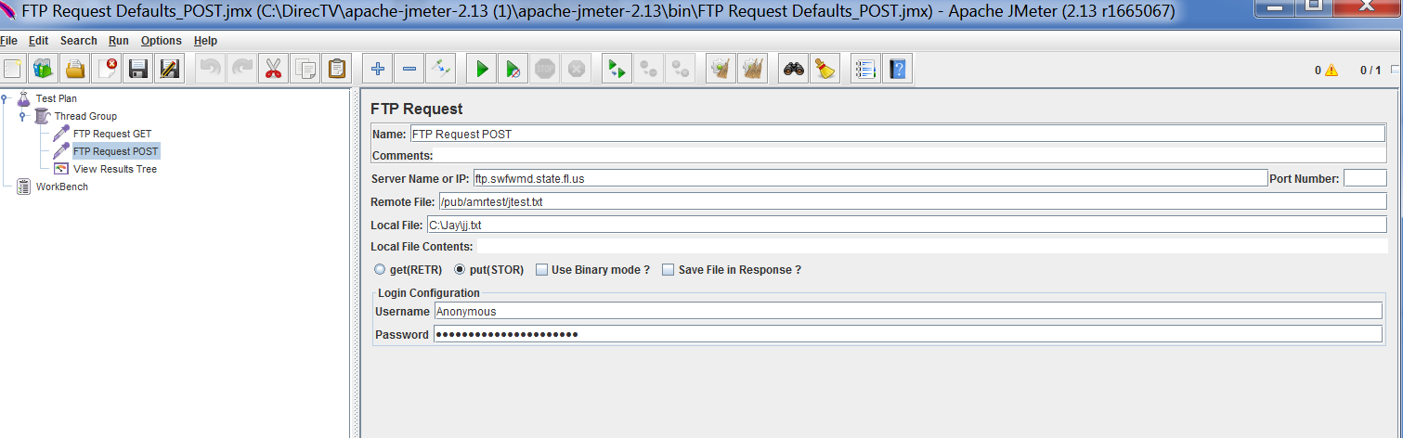

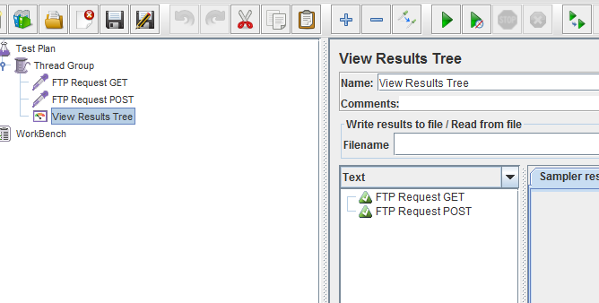

Let’s check the uploaded file “jtest.txt” in server through FTP Client software

Don’t forget to refresh the files and folders list in FileZilla

